**Circuit and System-I**

**LAB # 03**



**Spring 2019**

Submitted by: **Shah Raza**

Registration No.: **18PWCSE1658**

Class Section: **B**

“On my honor, as student of University of Engineering and Technology, I have neither given nor received unauthorized assistance on this academic work.”

Student Signature: ______________

Submitted to:

**Engr. Muneeba Ashfaq**

5 March, 2019

Department of Computer Systems Engineering

**Title:**

Verification of **OHM’s** law using PSPICE

**Objectives** :

* To find current in the wire using PSPICE software.
* We will be able to use PSPICE.
* We will be able of to use OHMs Law.

**Ohms law:**

**Definition**:

Ohm’s law states that the current in an electric circuit is proportional to the applied voltage and inversely proportional to its resistance*.*

Mathematical Expression:

V = IR

**Circuit Diagram :**

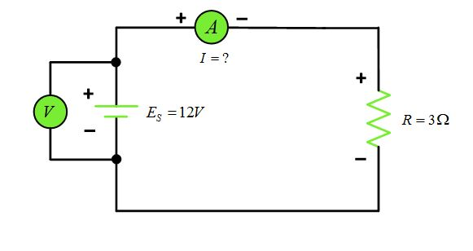

**PSPICE:**

**Intoduction:**

**PSpice** is a SPICE analog circuit and digital logic simulation software that runs on personal computers, hence the first letter "P" in its name. It was developed by MicroSim and is used in electronic design automation. MicroSim was bought by OrCAD which was subsequently purchased by Cadence Design Systems. The name is an acronym for Personal Simulation Program with Integrated Circuit Emphasis. Today it has evolved into an analog mixed signal simulator.

OR

“PSPICE is a circuit analysis tool that allows the user to simulate a circuit and extract key voltages and currents.”

**STEPS**:

* Go to start menu and search for Schematics.
* Select “Menu Draw”. Get new parts.
* Then click the “Libraries” button (You will get a window named as Library Brower).
* Go to “Part Browser Basic”, input the device name in the “Part Name” or select it in the bottom catalog.
* Click “Place” button, then you can put the selected devices into you schematic.
* Connect the devices you have put onto your schematic, use menu “Draw Wire“, your cursor would change to be a pencil.
* Check your circuit carefully, compare it with the circuit in your Lab Pak. Check the name and value of every device.
* Save your schematic.
* Use the menu “Analysis Setup” to set up the simulation condition.
* Use the menu “Analysis Simulation”.

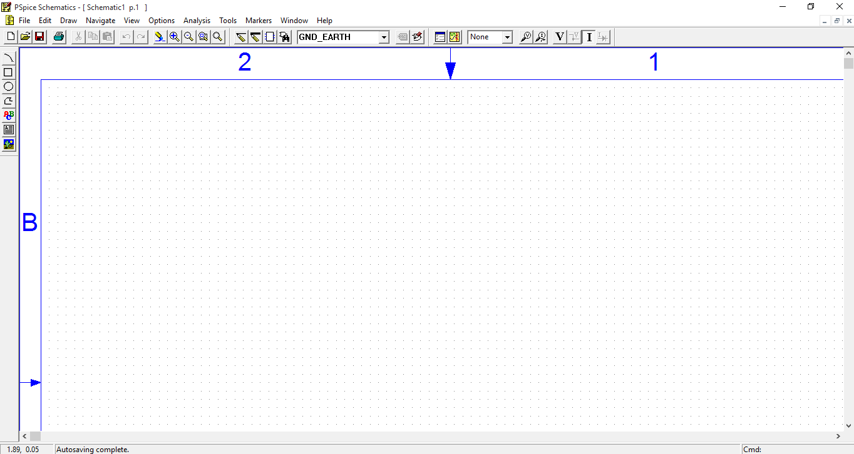

**Case 1:**

Voltage of 5v and resistance of 1kΩ.The current in this circuit is 5.00mA.

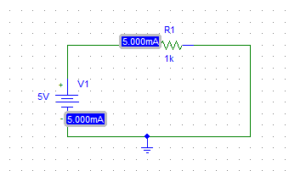

**Case 2:**

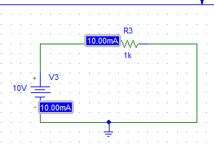 Voltage of 10v and resistance of 1kΩ.The current in this circuit is 10.00mA.

**Case 3:**

Voltage of 15v and resistance of 1kΩ.The current in this circuit is 15.00mA.

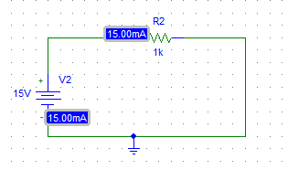

**Case 4:**

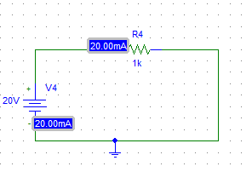 Voltage of 20v and resistance of 1kΩ.The current in this circuit is 20.00mA.

**Case 5:**

Voltage of 25v and resistance of 1kΩ.The current in this circuit is 25.00mA.

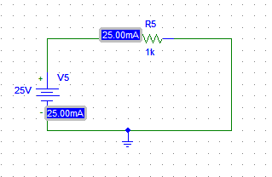

**Case 6:**

Voltage of 30v and resistance of 1kΩ.The current in this circuit is 30.00mA.

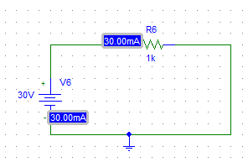

**Case 7:**

Voltage of 35v and resistance of 1kΩ.The current in this circuit is 35.00mA.

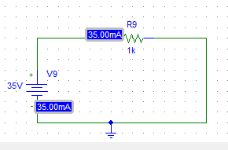

**Case 8:**

Voltage of 40v and resistance of 1kΩ.The current in this circuit is 40.00mA.

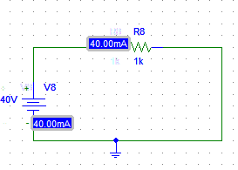

**Case 9:**

Voltage of 45v and resistance of 1kΩ.The current in this circuit is 45.00mA.

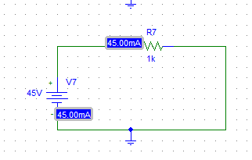

**CASE 10:**

Voltage of 50v and resistance of 1kΩ.The current in this circuit is 50.00mA.

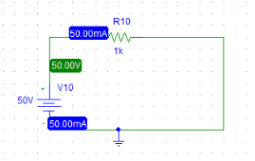

**OBSERVATION:**

|  |  |  |  |
| --- | --- | --- | --- |
| **S.No** | **Voltage**  **(Volts)** | **Resistance**  **(Ohms)** | **Current**  **(Amperes)** |
| **1** | **5 V** | **1k Ω** | **5 mA** |
| **2** | **10 V** | **1k Ω** | **10 mA** |
| **3** | **15 V** | **1k Ω** | **15 mA** |
| **4** | **20 V** | **1k Ω** | **20 mA** |
| **5** | **25 V** | **1k Ω** | **25 mA** |
| **6** | **30 V** | **1k Ω** | **30 mA** |
| **7** | **35 V** | **1k Ω** | **35 mA** |
| **8** | **40 V** | **1k Ω** | **40 mA** |
| **9** | **45 V** | **1k Ω** | **45 mA** |
| **10** | **50 V** | **1k Ω** | **50 mA** |

**GRAPH BETWEEN VOLTAGE AND CURRENT:**

**Conclusion:**

From this we concluded that voltage is directly proportional to the current when the resistance is constant. Or if we keep any one of these constant, other two are proportional.